Patricia Hajjar

Interactive Design 2

September 5th, 2016

Project 2: Marketing Campaign

Customer Service Excellence Training with YouthBuild USA

Through this project, I will be showing just one of the ways Starbucks is committed to creating opportunities and employment for youth around the world. The Costumer Service Excellence Training program is a collaboration with YouthBuild USA and the Schultz Family Foundation to help young people from disadvantaged backgrounds get the skills and training needed to succeed for careers in retail and customer service. The program is an 8-10-week class, which provides 80 hours of classroom and on-the-job training of technical retail and barista skills, and 80 hours in a customer service role in retail or café settings. It is very similar to the training approach that Starbucks baristas receive. After completing the required training, the young graduates receive four semester hours, a paycheck, and assistance with their job search, applications, interview preparation, and placement.

According to the chairman, president, and ceo of Starbucks, Sheri and Howard Schultz, “…this is so much more than a training program. It’s a chance for participants to gain direction, purpose, and positive reinforcement”. The goal of this initiative is to see young people grow with more self-confidence and passion who are able to rewrite the course of their lives. Graduates of the program have found jobs at Starbucks, and other opportunities with retailers, coffee shops, and small business. YouthCare and FareStart were the original inspirations for Starbucks to pursue this mission. YouthCare provides life skills coaching, resume and job search support, and connections to other services, while FareStart offers classroom training in food prep and on-the-job training at its café. Starbucks joined these non-profit organizations and created something new.

The purpose of this project is to promote the Customer Service Excellence Training program, and to encourage people to become involved and get more information through a call to action. The target demographic of the banner ad and overall campaign are young adults ages 16-24 years old, but also parents who are seeking educational and professional opportunities for their children. A storyboard will lay out the initial concept for the animated banner ad, as well as the copy and CTA. Graphic illustrations will be used to communicate the message in a simple and clear, yet fun and visually pleasing way. The microsite will provide additional information about the initiative, provide testimonials and images, and include a form to collect user information. The following images serve as visual inspiration and reference for the imagery and copy used on Starbucks website for this program.

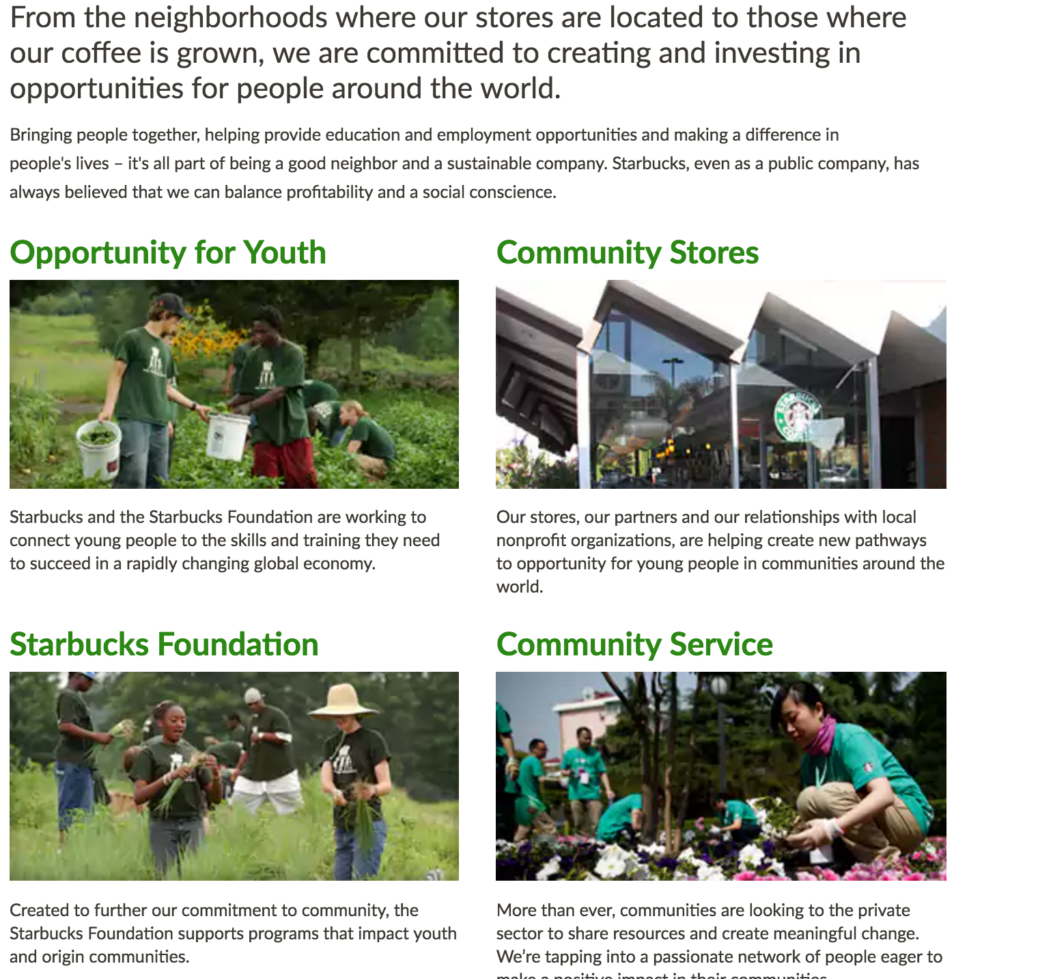

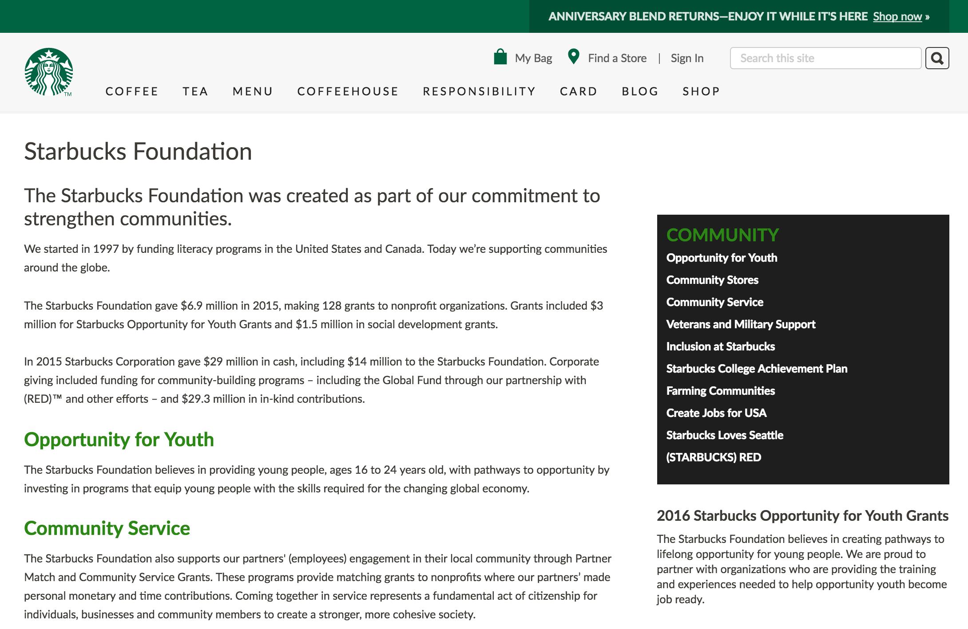

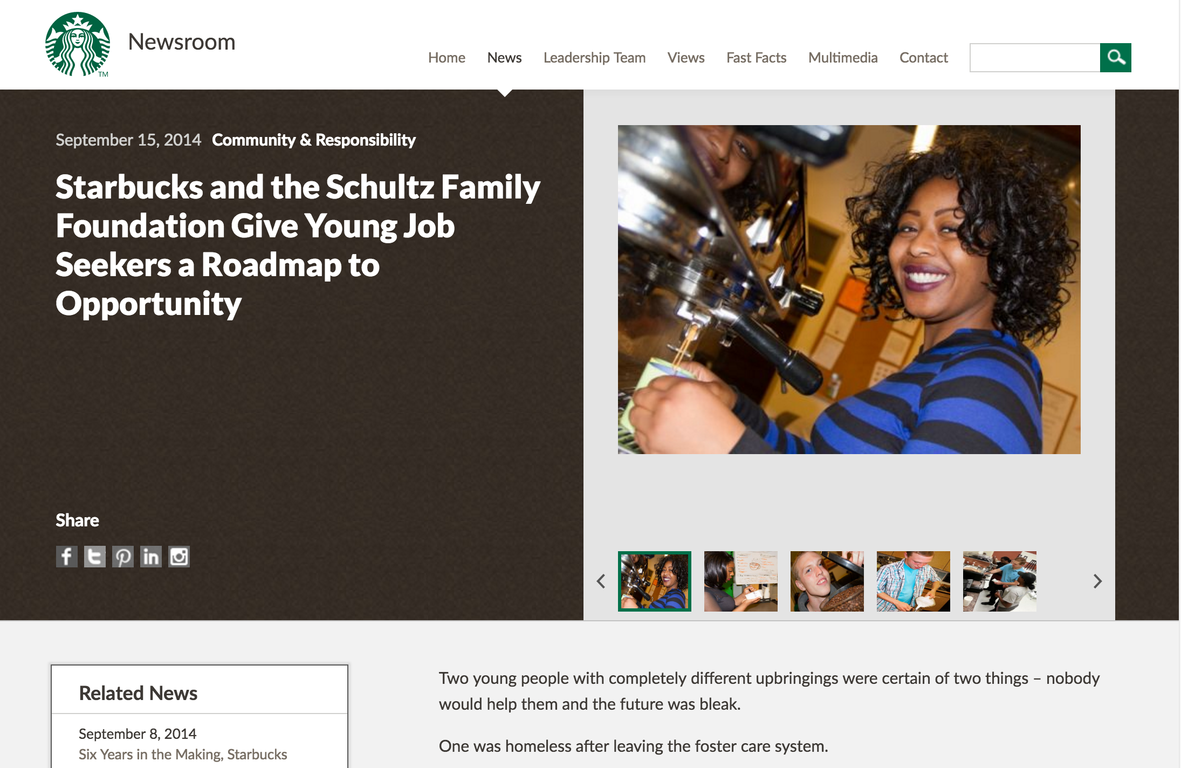

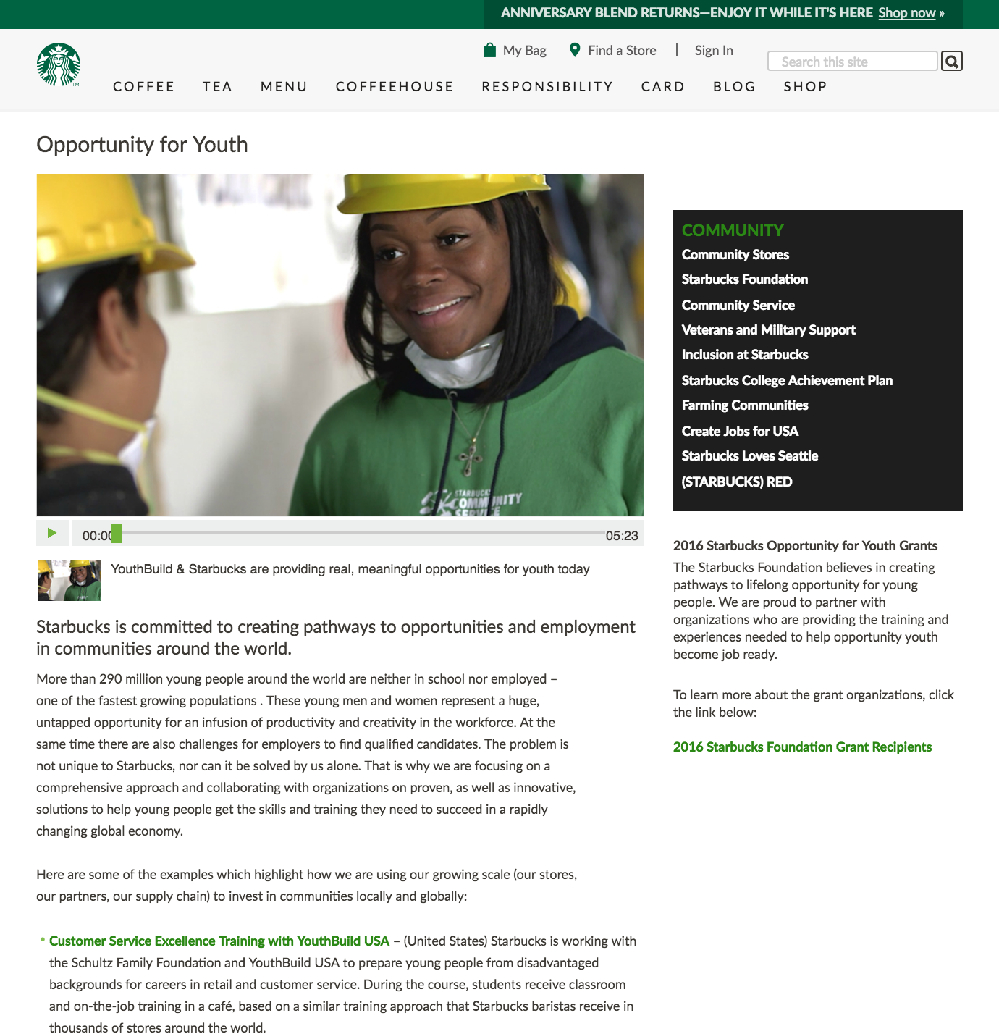

**Concept (original phrasing):** We are not afraid of using the word love. love in its purest human form. That’s why we partnered with YouthBuild USA to create our customer service excellence training program. designed for young people who are looking for a pathway to opportunity. Because we believe that in order to be successful, you need love.